
ELIAS PARK PRIMARY SCHOOL
END-OF-YEAR EXAMINATION 2020
PRIMARY 3
SCIENCE
BOOKLET A

Date: 2 November 2020
Total Time (Booklets A and B): 1 h 30 min

DO NOT OPEN THIS BOOKLET UNTIL YOU ARE TOLD TO DO SO.
FOLLOW ALL INSTRUCTIONS CAREFULLY.

THIS BOOKLET CONSISTS OF 23 PRINTED PAGES AND 1 BLANK PAGE (INCLUDING THE COVER PAGE).

NAME | : | ________________________________________ | ( )
CLASS | : | PRIMARY 3 _________________

PART I

For each question from 1 to 24, four options are given. One of them is the correct answer. Make your choice (1, 2, 3 or 4). Shade the correct oval (1, 2, 3 or 4) on the Optical Answer Sheet. (24 x 2 marks)
___________________________________________________________________

1 The graph below shows the height of Animal Q over 5 months.
height (cm)
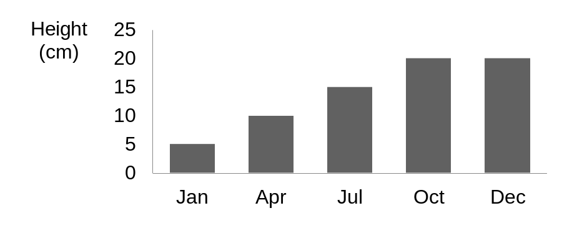

month
Jan
Feb
Mar
Apr
May

Based only on the graph, what can we conclude about Animal Q from January to May?

- Animal Q grew taller.
- Animal Q reproduced.

- Animal Q increased in size.
- Animal Q increased in mass.

2 Bala placed 50g of food in three containers, X, Y and Z. He recorded the amount of food and water left after three days.

container | amount of food (g)
container | at the beginning of the experiment | at the end of the experiment
X | 50 | 14
Y | 50 | 50
Z | 50 | 5

Based on the information above, which containers, X, Y and/or Z, have living
things in them?

- X and Y only

- X and Z only

- Y and Z only

- X, Y and Z

3 Study the classification chart below.

things
group Q
group R
Which of the following can be correctly grouped into groups Q and R?
paper
water
oil
ant
flower
cow

 | group Q | group R
(1) | Air | robot
(2) | Robot | lizard
(3) | Stone | air
(4) | Lizard | stone

4 The table below shows the characteristics of A, B, C and D.
 | able to move from place to place | needs water | reproduces | has legs
A | ✓ | ✓ | ✓ | ✓
B |  |  |  | ✓
C |  | ✓ | ✓
D | ✓ | ✓ | ✓
Which is most likely to be a non-living thing?

- A

- B

- C

- D

5 The following table gives information on two plants, P and S, based on two characteristics. A tick (P) shows that the plant has the characteristics.

characteristic | plant P | plant S
has flowers |  | P
grows on land | P | P
From the information above, where do plants P and S belong in the following classification table?
plants

E
F
G
H
flowering
non-flowering
land
water
land
water
 | plant P | plant S
(1) | G | H
(2) | F | E
(3) | H | F
(4) | G | E
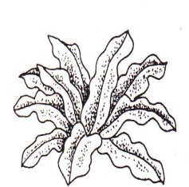
6 The pictures below show a mushroom and a bird’s nest fern.
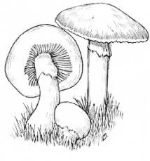

bird’s nest fern
mushroom

Which one of the statements below is true?

- Both reproduce by spores.

- Both need sunlight for survival.

- Both can make food on its own.

- Both are able to produce flowers.

7 Zhiwei used a swimming board to swim in the water as shown below.

swimming board

What characteristic(s) must the swimming board have?

A It must be flexible.

B It must float on water.

C It must be waterproof.

D It allows most light to pass through it.

- B only

- A and D only

- B and C only

- C and D only
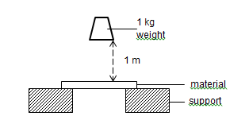
8 Mdm Laila conducted the experiment below to investigate the strength of four different materials, W, X, Y and Z. She dropped a 1 kg weight from a height of 1 metre as shown in the set-up below. The materials were of the same size, thickness and shape.
1-kg weight
material
support
1 kg weight
1 m

She recorded the number of times the weight was dropped before the materials broke. Her results are shown in the table below.
material | number of times the weight was dropped before the material broke
W | 5
X | 3
Y | 10
Z | 7

Based on the observations above, which one of the following statements is correct?

- Material Y is the weakest material.

- Material X is the strongest material.

- Material W is weaker than Material X.

- Material Z is stronger than Materials W and X.

9 The flowchart below is used to classify 4 objects, A, B, C and D.

object
Which one of the following objects, A, B, C or D, would most likely be a bath towel?
yes
yes
Is it light?
Is it flexible?
Is it
waterproof?
D
A
B
C
no
no
no
yes

- A
- B
- C
- D

10 Z shows a part of the human skeletal system.

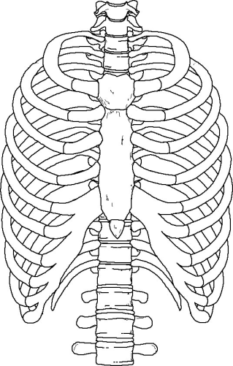

Z

What is the main function of Z?

- To give the body its shape.

- To protect important organs.

- To provide support for the body.

- To work with the muscular system to allow body movement.

11 Study the flowchart below.

human body systems

Does it help the body to move?
Does it protect our organs?
Does it take in air for the body?
Z
XX
Y
yes
no
yes
no
no

yes

W

Which one of the following is likely to be the circulatory system?

- W

- X

- Y

- Z

12 Study the human body system diagrams below carefully.
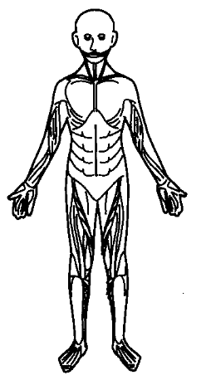
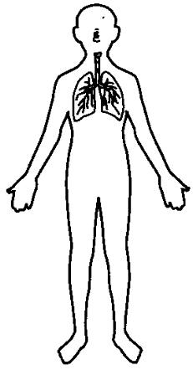
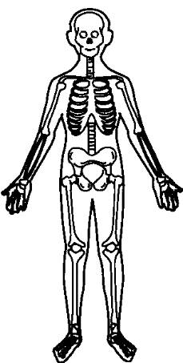

A B C
Which system(s) is/are involved when Pravin is playing soccer?

- C only

- A and B only

- B and C only

(4) A, B and C

13 Which of the following statements about saliva are true?

A Helps to digest food.
B Contains digestive juice.
C Makes food easier to swallow.
D Helps food to be absorbed in the stomach.

- A and C only

- C and D only

- A, B and C only

- A, B and D only

14 The diagram below shows a human digestive system.

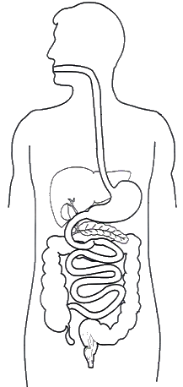
Which of the following shows the correct organs of where digestion starts and ends?
A

B

C

D

E

 | start of digestion | end of digestion
(1) | A | D
(2) | A | E
(3) | B | D
(4) | C | E

15 Pei Wen wanted to find out if the amount of digestive juice affects the
digestion of cooked rice.

She prepared the following set-ups for her experiment.

Set-up | Amount of digestive juice  (ml) | Amount of cooked rice  (g) | Type of rice | Time taken for the experiment (min)
P | 5 | 20 | white | 25
Q | 10 | 25 | brown | 30

Her father said her experiment is not fair.

Which of the following variable(s) should she keep the same so that her experiment is fair?

A The type of rice.

B The amount of cooked rice.

C The amount of digestive juice.

D The time taken for the experiment.

- C only

- A and C only

- B and D only

- A, B and D only

16 Hanis conducted an experiment to find out if roots absorb water using
set-ups A and B as shown below. Both set-ups contain 500 ml of water. 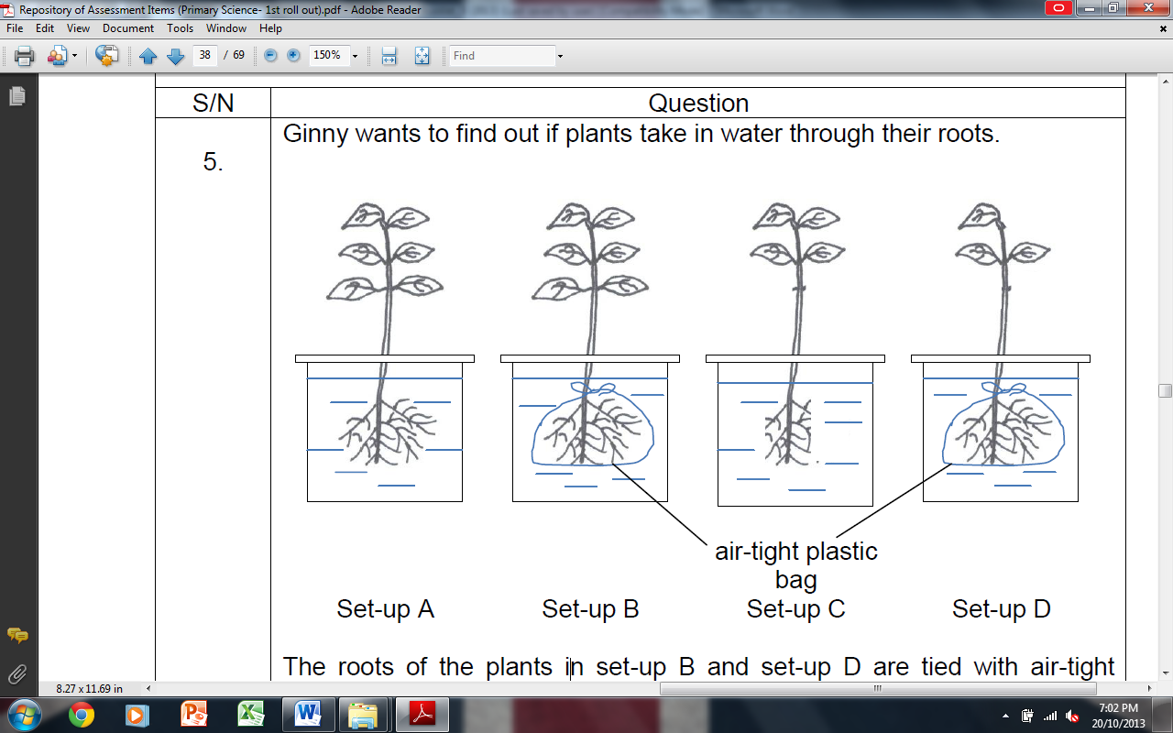
set-up A
set-up B
plastic bag

What should she measure to find out if the roots absorbed water after 7 days?

- The number of roots.

- The length of the roots in each set-up.

- The number of leaves left in each set-up.

- The amount of water left in each container.
17 A group of students went to the garden to observe the growth of a plant. The
pictures below show the different stages X and Y of the same plant.

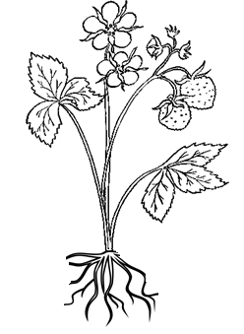

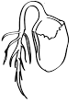

stage X
stage Y

They wrote down statements about the stages of growth in the plant.

Raj The plant can reproduce at stages, X and Y.
Qisya The plant is able to make food at stage Y but not at
stage X.
Si Hui The plant is able to take in water and mineral salts at both stages X and Y.

Who made the correct statement(s)?

(1) Raj only
(2) Si Hui only
(3) Qisya and Raj only
(4) Qisya and Si Hui only

18 A magnet as shown in the diagram below, was lowered into a tray of pins.
The magnet attracted some pins.

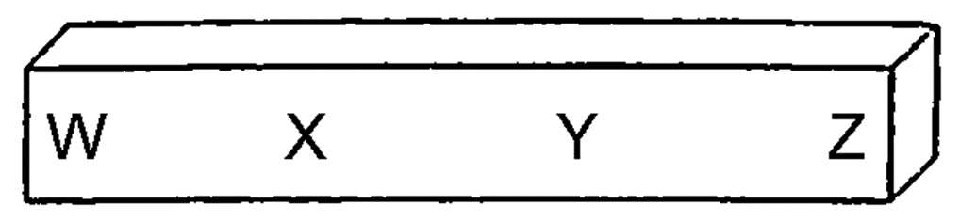
The results of the number of pins attracted to each position of the magnet were recorded in a table as shown below.

position on the magnet | number of pins attracted
W | 15
X | 3
Y | 4
Z | 13

What is the aim of this experiment?

- To find out how strong this magnet is.

- To find out which part of the magnet is the strongest.

- To find out if the pins would be attracted to the magnet.

- To find out which is the like and unlike poles of the magnet.

19 The following diagram shows how three bars X, Y and Z interact with one another.

repel
X
Y

attract
Y
Z

repel
Z
X

Based on the above observation, which one of the following conclusions is correct?

- Only bar X is a magnet.

- Bars X, Y and Z are magnets.

- Only bar X and Z are magnets.

- Bar Y is a magnetic material but not a magnet.

20 Suhaimi arranged two magnets, KL and MN, and an iron bar YZ as shown below.
Y
iron bar

He then rearranged the magnets and the iron bar.
Which one of the following rearrangements is possible?
(1) (2)
K
L
N
M
N
M
Z
Y
K
L
M
N
I
L
M
N
Y
Z
K
Z

J

(3) (4)
K
L
N
M
N
M
Z
Y
M
N
Z
Y
L
K
21 The diagrams below show four set-ups, A, B, C and D.
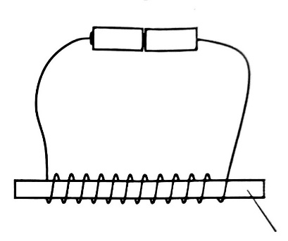

copper rod
wood rod
set-up A
set-up B

set-up C
set-up D

steel rod
plastic rod

Which of the following set-up(s) can be used to make electromagnet?

- Set-up C only

- Set-ups A and B only

- Set-ups A and C only

- Set-ups C and D only

22 Anita conducted an experiment by dipping each of four different magnets W,
X, Y and Z into a box of paper clips.
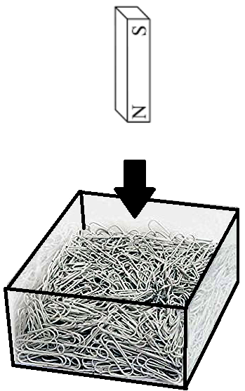

bar magnet

box of paper clips

She then counted the number of paper clips left in the box after dipping each magnet in and out of the box. She recorded her results in the graph below.

number of paper clips left in the box after dipping

magnet
W
X
Y
Z

Based on the graph, which of the following statements is correct?

- Magnet Y is weaker than magnet X.

- Magnet Z is weaker than magnet W.

- Magnet X is stronger than magnet Z.

- Magnet W is stronger than magnet X.

23 Lisa used the set-up below to attract steel clips.

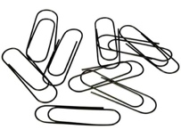
rod
batteriesees
turns of wire
steel clips
She increased the number of turns of wire around the rod and recorded her results in the table below.

number of turns around the rod | 5 | 10 | 15 | 20 | 25 | 30
number of steel clips attracted | 0 | 2 | 4 | 6 | 8 | 10

Based on the results in the table above, what is the relationship between the number of turns around the rod and the strength of the electromagnet?

- When the number of turns around the rod increased, the strength of the electromagnet increased.

- When the number of turns around the rod decreased, the strength of the electromagnet increased.

- When the strength of the electromagnet increased, the number of turns around the rod decreased.

- When the strength of the electromagnet increased, the number of turns around the rod increased.
24 Ranvir wants to find out whether the magnetic strength of a temporary magnet increases as the number of strokes increases. He stroke the rod from left to right.

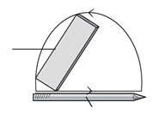

magnet

rod

In order to carry out a fair test, what are the variables that need to be kept the same?

A The number of strokes
B The size of the iron nail

C The type of magnet used for stroking

- A only

- B only

- B and C only

- A, B and C

END OF BOOKLET A

BLANK PAGE

